**Our Lady of Guadalupe**

**Mother of the Americas Patroness of Our Province**

**December 12 in most of the Americas is the feast of Our Lady of Guadalupe. It commemorates the Blessed Virgin Mary’s appearance to the Indian peasant Juan Diego in 1531 on the rocky hill of Tepeyac near Mexico City. She was dressed in a pink gown with a green sash, the typical dress of pregnant women of the time. Over her head and her body she had a blue star studded mantle, similar to the clothing of Aztec women.**

**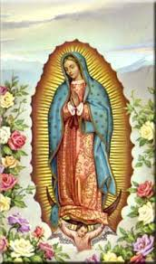**

**Her message, “Build me a church,” extends far beyond the basilica built on the site. This message has spread throughout Central and South America and to the Philippines as the people struggle today to build a church – to become a community of disciples who are the people of God.**

**Our Lady of Guadalupe is the only appearance of Mary in the Americas that is officially recognized by the Church. In 1945, Pope Pius XII designated her “Patroness of all the Americas” and in 1961 Pope John XXIII invoked her as “Mother of the Americas.”**

**This feast also reminds us that our ethnic differences contribute to the wholeness and blessed diversity of the People of God. Hispanic Catholics, including those in the Philippines, are especially devoted to her and joyously celebrate her day with mariachi music, liturgies, dancing, meals, the re-telling of the story and an abundance of roses in December. Her shrine in Mexico City is the second most popular shrine (after the Vatican) in the Catholic world.**

**Let us pray, at this time, to Our Lady of Guadalupe to bring an end to the pandemic.**

*~ All Saints Press, St. Louis, MO. ~ with thanks to Sr. Grace Waters, MSC*

**As Pandemic Devastates Latin America,**

**Pope Francis Prays to St. Juan Diego**

*~ by Junno Arocho Esteves, Catholic News Service*

VATICAN CITY (CNS) - Pope Francis sought the intercession of the first indigenous saint of the Americas as COVID-19 continued to devastate many Latin American countries.

While greeting Spanish-speaking faithful during his weekly general audience on December 9th, the Pope marked the feast day of St. Juan Diego, “whom Our Lady of Guadalupe chose as her envoy.”

The Marian apparitions took place in 1531 on Tepeyac Hill in Mexico, now the site of the Basilica of Our Lady of Guadalupe which houses Juan Diego’s tilma, the mantle that bears the miraculous image of Mary.

Pope Francis prayed, “Through his intercession, may he present to Our Lady the countries of Latin America, affected by the pandemic and natural disasters, so that she, as a mother, may go out to meet her children and cover them with her mantle.”

According to a December 8 report by Bloomberg News, Latin America accounts for 30% of the deaths related to COVID-19.

In July, the Pan American Health Organization stated that the pandemic posed a particularly great risk for indigenous communities, especially those “living in remote settlements or isolated areas where access to health services is a challenge.”

“Among indigenous populations, either living in remote settlements or isolated in urban areas, some of the risk factors that may be associated with higher COVID-19 mortality rates include malnutrition, insufficient access or complete lack of access to health systems as well as to potable water and basic sanitation, in addition to the existing high burden of parasitic diseases,” the organization said.

In a November 19 video message to participants at a virtual seminar about the coronavirus pandemic in Latin America, Pope Francis called on government leaders not to exploit the COVID-19 pandemic as a means to discredit political rivals but instead set aside differences to find “viable solutions for our people.”

**Weekly Update – Publication Notice**

**Due to scheduling in the Guadalupe Province Communications Office, the final edition of The Update for 2020 will be on TUESDAY, December 15th. We ask that all submissions be received by the end of business day on Monday, December 14th.**

**The Update will resume publication on Thursday, January 7, 2021.**

Anti-trafficking Advocates Warn the Pandemic

is Increasing Human Trafficking

*~ by Chris Herlinger, Global Sisters Report*

Those involved in efforts to end human trafficking fear that the global pandemic and resulting lockdowns are increasing the numbers of people forced into human trafficking.

“The broad upshot is that we need to brace ourselves for 2021 and expect a huge increase in the number of people affected” by trafficking, Luke de Pulford, director of the U.K.-based anti-trafficking organization  [Arise](https://www.arisefdn.org/), said during a Dec. 2 webinar by the [Catholic Sisters Initiative](https://www.hiltonfoundation.org/programs/catholic-sisters) of the [Conrad N. Hilton Foundation](https://www.hiltonfoundation.org/).

“We don’t know how bad the damage is yet,” de Pulford told the Global Sisters Report (GSR), “but when the statistics come in they are going to be deeply shocking and troubling.”

Those being lured into trafficking work – be it slave labor or sexual trafficking – are those “already struggling” and at risk due to poverty, Sr. Jane Wakahiu, Associate Vice President of Program Operations of Hilton’s Catholic Sisters initiative.

“COVID has exacerbated a dramatic increase in unemployment, reduced or loss of income for individuals working in informal or low wage sectors which leads to vulnerability, and at-risk individuals find themselves in precarious circumstances, Sr. Wakahiu told GSR.

In his presentation, de Pulford cited some grim realities:

In October, the World Bank said that global poverty is expected to rise in 2020, with the COVID-19 pandemic “estimated to push an additional 88 to 115 million people into extreme poverty this year.

“The principal underlying cause of human trafficking is poverty and the search for better economic opportunities. Prevention is impeded not just by levels of poverty itself but by a series of vulnerabilities, including armed conflict and migration, homelessness, disabilities, lack of supportive families, and racial and ethnic prejudice.”

Another concern, de Pulford said is the mass movement of people – with “lockdowns and business closures [prompting] millions of workers to try to return to their homes. Not all of the newly unemployed reach home. Many turn to illegal means to sustain themselves.”

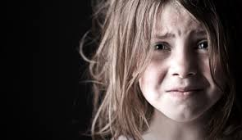

Child trafficking is also likely increasing, de Pulford said, “with alarming trends indicating that worse is to come.” That is because an estimated 42 to 66 million more children “could fall into extreme poverty and nearly 1.5 billion children around the world have been kept away from school for three months under national lockdowns.”

“The Conrad N. Hilton Foundation supports Catholic sisters in the fight against human trafficking because sisters have taken a strategic leadership stance and pooled their efforts to create an international network of consecrated life against trafficking in persons,” said Sr. Wakahiu. “Sisters have not only demonstrated their capability but are in the frontline supporting in prevention, protection, prayer and rehabilitation of survivors. Survivors need a variety of support, including psychological, healthcare, spiritual, and connections to employment. Sisters recognize every person’s dignity; they don’t judge but walk with the individual in their journeys of healing and wholeness.”

To read the entire article click [here](https://www.globalsistersreport.org/news/ministry/news/anti-trafficking-advocates-warn-pandemic-increasing-human-trafficking) To learn more about the Cabrinian efforts to combat human-trafficking, click [here](https://www.mothercabrini.org/who-we-are/our-corporate-stances/stop-human-trafficking/) and [here](https://www.mothercabrini.org/what-we-do/anti-human-trafficking/) To access a PDF with the Missionary Sisters Guadalupe Province Corporate Stance on Anti-Human Trafficking. Click [here](https://www.mothercabrini.org/who-we-are/our-corporate-stances/stop-human-trafficking/)

**A Dual Celebration**

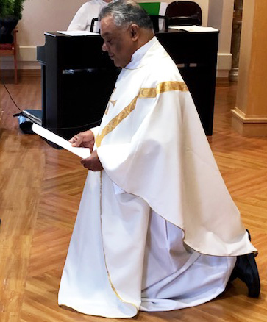Not only was Tuesday, December 8th the celebration of the Feast of the Immaculate Conception of the Blessed Virgin Mary, it was also a very special day for Cabrini of Westchester’s Chaplain, Fr. Thomas Vadakemuriyil, CMI. Father Thomas renewed his religious vows during the 11:00 Mass in Cabrini of Westchester’s Chapel, witnessed by several staff members, as well as, all the residents who were watching the televised Mass from their rooms. Each year, the Carmelites of Immaculate Mary renew their religious vows on the Feast of the Immaculate Conception, since the first eleven members of the congregation professed their vows on December 8, 1955.

Father Thomas expressed his appreciation to all those who attended, and shared that since he was not living in a congregation with fellow priests to celebrate this occasion, he was very pleased to be celebrating with his Cabrini Family.

Father Thomas renews his religious vows in the Cabrini of Westchester Chapel.

Before the conclusion of Mass, Vice President of Operations and Administrator, Bonnie Burke, offered congratulations to Father Thomas saying, “Here at Cabrini, we are the recipients of the gift of your faithfulness to God and the Church. Thank you for your service, thank you for weaving the thread of the scripture of Holy Mass and guiding us into the truth, encouraging us to keep a focus on Jesus. Your pastoral care is an authentic expression of this gift. On behalf of our staff and all the residents, we wish you happiness and deep commitment.”

~ *submitted by Susan Herceg, Cabrini of Westcheste*

Incoming Administration’s Climate Agenda Reflects

the Spirit of Laudato Si’

~ *by Daniel Horan, Earth Beat of National Catholic Reporter*

Pope Francis, who played a significant spiritual and nongovernmental role in promoting the Paris Agreement in 2015, issued his influential encyclical letter "[Laudato Si', on Care for Our Common Home](http://www.vatican.va/content/francesco/en/encyclicals/documents/papa-francesco_20150524_enciclica-laudato-si.html" \t "_blank)" the same year.

Pope Francis, in his congratulatory call to Joe Biden last month emphasized areas of common ground between the church’s social teaching and the Biden administration’s priorities including

"[addressing the crisis of climate change](https://thehill.com/changing-america/sustainability/climate-change/525774-pope-francis-discusses-climate-change-on-first)." The incoming Biden administration appears poised to implement many of the policies and practices that align with Francis’ repeated calls for personal and collective “ecological conversion” as expressed in *Laudato Si’*.

Here is an illustrative set of five key alignments with those of economist and journalist Nishan Degnarain in his article in Forbes Magazine. (Click [here](https://www.forbes.com/sites/nishandegnarain/2020/12/04/10-actions-climate-envoy-john-kerry-can-take-to-win-the-climate-war/?sh=3c7e7a116cc9) )

* ***Taking science seriously:*** Take seriously the scientific evidence for “what is happening to our common home”. Embrace expertise and scientific research in formulating policies and responding to crises.
* ***Environmental justice for poor and marginalized:*** Call for a paradigm shift in how we approach issues of society and the natural environment, recognizing their inherent relationship and interconnectedness. The Biden Plan explicitly acknowledges how climate change and pollution disproportionately affect poor and minoritized communities and the need to correct such injustices.
* ***Intergenerational solidarity:*** Francis writes, “Intergenerational solidarity is not optional, but rather a basic question of justice since the world we have received also belongs to those who follow us.”
* ***International collaboration:*** Returning America to the international stage will strengthen partnerships necessary to respond to the existential climate threat as well as other crises that will inevitably rise.
* ***Economy in dialogue for human fulfillment:*** Francis in *Laudato Si’* reemphasized the centrality of the common good as the foundational principle of governance and international cooperation. The Biden Administration has proposed a number of clean energy and economic initiatives aimed at sustaining dialogue between the economy and the environment, striving to connect our coordinated response to climate change with economic justice and growth.
* To read the entire article click [here](https://www.ncronline.org/news/earthbeat/faith-seeking-understanding/biden-administrations-climate-agenda-reflects-spirit)

The CLM Corner

***The CLM Corner provides***

***periodic updates on the Cabrini Lay Missionaries of the***

***Guadalupe Province and their ministerial works.***

Discerning their CLM Call

When someone feels called to be a Cabrini Lay Missionary (CLM), he or she begins a time of discernment. This time of initial formation helps a person to deepen their knowledge and love of the scriptures, teachings of the church, their own spirituality, the Sacred Heart Spirituality, etc. In addition, they learn more about the life of Mother Cabrini and about the Missionary Sisters of the Sacred Heart (Cabrini Sisters) and their ministries.

CLM Director Lorraine Campanelli (top row, center) invited Sr. Catherine Garry, MSC (top row, right) to speak with those who are currently discerning their call to be a Cabrini Lay Missionary. CLM Adela Jarquin (middle row, left) and Srs. Christine Marie Baltas and Grace Waters (middle row, right) joined in the conversation, as well.

We are blessed to have five people who are discerning their call to be a CLM. This past Saturday, via Zoom, Sr. Catherine Garry, MSC, gave a beautiful presentation about the Missionary Sisters of the Sacred Heart to those in formation. Some of the topics presented were:

* the Global Presence of the Sisters
* the different Provinces of the Institute
* the Guadalupe Province Corporate Stances – on immigration and anti-human trafficking
* the various missions and ministries of the Province and Institute
* the governance of the Province and Institute
* the direction where the Spirit has led and continues to lead the religious community.

Thank you to Sr. Catherine for your presentation. Another important piece of formation is getting to know the Cabrini Sisters.

Thank you to Sr. Christine Marie Baltas, MSC and Sr. Grace Waters, MSC for joining us. What a wonderful way to become better acquainted with the Sisters. Thank you also to Adela Jarquin, one of the founding CLMs, for joining us!

I am so grateful for the gift of technology. Zoom has truly been a blessing.

*~ submitted by: Lorraine Campanelli, Director of the CLMs (Guadalupe Province)*

**Christmas & Children**

**will triumph over COVID-19**

Sadly, Cabrini Immigrant Services-NYC cannot host our Annual Holiday Celebration this December. Undaunted, we have decided on a scaled-back and socially distanced gift distribution for our immigrant families.

This year the distribution is planned to be on Saturday, December 19th. Sr. Yolanda has set-up a gift registry for the children on Target’s website which can be accessed at this link: tgt.gifts/cabrinichristmas

Toys will be sent directly to CIS so there is no need to visit the post office! **The deadline for ordering from Target is Saturday, December 12th.**

We are also grateful for gifts of cash to cover the incidental expenses of the distribution day. Monetary donations can be made at: bit.ly/donatecis

Thank you for helping CIS-NYC care for the immigrant children in our community!

*~ submitted by Julia Mucci and Ella Nimmo*

**Save the Dates**

**for a Compelling Webinar Series on Immigration:**

**“Dreaming of a Single Human Family”**

Sponsored by:

**The National Shrine of St. Frances X. Cabrini, Chicago, IL**

**in collaboration with**

**The Cabrini Retreat Center, Des Plaines, IL**

**WEDNESDAY, JANUARY 27, 2021**

**9:00 am MST/10:00 am CST/11:00 am EST**

**“Themes from the Life and Spirituality of Mother Cabrini, Patroness of Immigrants”**

[In this talk, Nicholas Rademacher and Michelle Sherman will discuss the integration of faith and justice in Mother Cabrini’s Gospel-inspired commitment to serve immigrant communities in the United States and Latin America.](webextlink://In%20this%20talk,%20Nicholas%20Rademacher%20and%20Michelle%20Sherman%20will%20discuss%20the%20integration%20of%20faith%20and%20justice%20in%20Mother%20Cabrini’s%20Gospel-inspired%20commitment%20to%20serve%20immigrant%20communities%20in%20the%20United%20States%20and%20Latin%20America.) Set within the context of major turning points in her life, their talk will explore Mother Cabrini’s missionary vocation, her devotion to the Sacred Heart of Jesus, and her spirit of *disponibilita’*, that is, her flexibility and openness to God’s call.

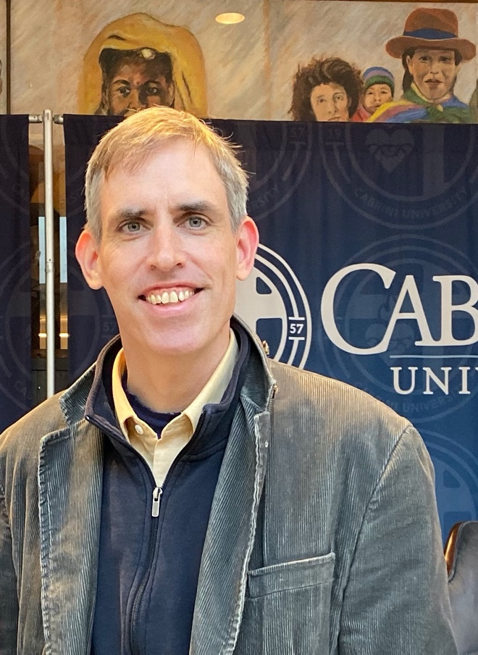

Presenters:

**Nicholas Rademacher, PhD**

Dr. Rademacher is professor and chair of Religious Studies at Cabrini University. His teaching and scholarship focus on historical and contemporary expressions of Catholicism in the United States. Dr. Rademacher earned his PhD at the Catholic University of America. A published author of journals and books, he serves as Vice President of the American Catholic Historical Society and recently completed service on the historical commission for cause for canonization of Fr. William Atkinson, OSA.

Dr. Rademacher can be reached via [nr725@cabrini.edu](mailto:nr725@cabrini.edu)

****

**Michelle Sherman, MA**

Michelle Sherman is the Campus Minister for Retreats at Villanova University. A former Cabrini Mission Corps missioner at Mother Cabrini H.S. in NYC, she is honored to contribute to this important Cabrini series. She holds a BA in Humanistic Studies from St. Mary’s College in Notre Dame, IN; a MA in Theology and Certification in Lay Ministry from Villanova University; and Certification in Spiritual Direction from the Cranaleith Spiritual Center.

Ms. Sherman can be reached at [michelle.sherman@villanova.edu](mailto:michelle.sherman@villanova.edu)

**“Dreaming of a**

**Single Human Family”**

**WEDNESDAY, FEBRUARY 24, 2021**

**9:00 am MST/10:00 am CST/11:00 am EST**

**The Center on Immigration:   
Challenges in Migration and a Cabrinian Response**

As global politics further restrict migration, push factors such as global inequality, unyielding violence, and irreversible climate change persist and intensify. This virtual webinar will provide a concise overview of challenges facing immigrant communities at a local, national, and international level. It will also address how The Center on Immigration at Cabrini University is responding to these challenges and provide suggestions for people seeking to work for justice with people in migration.

**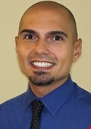**

Presenter:

**Abel Rodriguez, JD (’01)**

Abel Rodriguez is Director of the Center on Immigration and Assistant Professor of Religion, Law and Social Justice at Cabrini University. His scholarship, teaching and advocacy focus on migrant justice. He is an expert and frequent presenter on immigration policy and the intersection of criminal and immigration law. Rodriguez earned a Juris Doctor at U. of Penn, a Masters of Theological Studies at Harvard, and a Master of Arts in Latin American Studies at Stanford, and a Bachelor of Arts in Spanish at Cabrini College.

Mr. Rodriguez can be reached at: [ar3269@cabrini.edu](mailto:ar3269@cabrini.edu)

**WEDNESDAY, MARCH 24, 2021**

**9:00 am MST/10:00 am CST/11:00 am EST**

**“Immigration from the Perspective of the Cabrinian Charism, on a local, national and international level. Highlighting the focus of Cabrini University Wolfington Center”**

We will discuss some of the ways that the Wolfington Center at Cabrini University puts our commitment to solidarity with migrants into practice and look for ways that participants in the session can find new opportunities for engagement in their own communities.  Initiatives include a middle school mentoring program with newly arrived immigrants in Norristown, PA; immigration simulations through our CRS Ambassadors chapter; and a grant-funded faculty cohort focused on migration.

**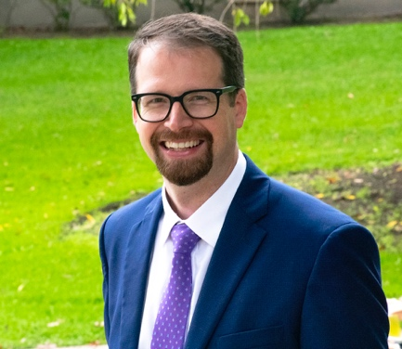**

Presenter:

**Raymond Ward, PhD**

Dr. Ray Ward is the Director of the Wolfington Center at Cabrini University He earned a PhD in Christian Ethics from Boston College, writing on the concept of collective moral agency and responsibility in the Christian tradition. He serves as an advisor to several student-run organizations and also teaches the Faith, Service and Advocacy and College Success Seminar.

Dr. Ward can be reached at: [rew68@cabrini.edu](mailto:rew68@cabrini.edu)

******

***Each week during the season of Advent, one of the Cabrini Lay Missionaries will be offering a reflection.***

**Third Sunday of Advent**

**December 13, 2020**

***This reflection by author and poet, Madeleine L’Engle is shared by CLM Marianne McGowan.***

**First Coming**

**He did not wait till the world was ready.**

**Till men and nations were at peace.**

**He came when the Heavens were unsteady,**

**And prisoners cried out for release.**

**He did not wait for the perfect time.**

**He came when the need was deep and great.**

**He dined with sinners in all their grime,**

**Turned water into wine.**

**He did not wait till hearts were pure.**

**In joy he came to a tarnished world of sin and doubt.**

**To a world like ours, of anguished shame**

**He came, his Light would not go out.**

**He came to the world that did not mesh,**

**To heal its tangles, shield its scorn.**

**In the mystery of the Word made Flesh**

**The Maker of the stars was born.**

**We cannot wait till the world is sane to raise our songs with joyful voice,**

**For to share our grief, to touch our pain,**

**He came with Love: Rejoice! Rejoice!**

Prayer Requests

***Joan Baltas***

Sr. Christine Marie Baltas, MSC requests prayers for her sister, Joan, who is undergoing some medical tests. Let us pray for a favorable outcome of all tests.

***Cabrini University staff member’s father***

An employee at Cabrini University asks for prayers for his aging father who will undergo a medical procedure on December 14th.

***Sr. Sharon Casey, MSC***

Kindly keep Sr. Sharon, who is recuperating from recent knee surgery, in your prayers. Pray that her recovery will be swift.

***Anita Catalanotto***

In your prayers, please remember Cabrini University staff member, Anita Catalanotto. Anita will be undergoing knee surgery on Friday, December 18th. Pray that her surgery will be successful and that she will quickly be on the road to recovery.

***John Flaherty***

Your prayers are invited for John, the nephew of Geraldine Flaherty, the administrator of the Sacred Heart Convent, who has suffered a major stroke. Pray that he will recover and be restored to full health.



***Sr.* *Mary Ann Hawes, MSC***

Sr. Mary Ann, unfortunately, had a fall on Tuesday at St. Cabrini Nursing Home, sustaining an injury that required a few sutures on her head. Pray that she will heal quickly.

***Irene McCormick***

Sr. Beth McCormick, OP requests prayers for her sister, Irene, who is experiencing heart problems. Pray that all will be well and that she will be restored to full health.

***Jack Nowry***

You are asked to pray for Jack Nowry, the brother-in-law of Sr. Arlene Van Dusen, MSC, who is having numerous medical issues at this time. Pray that all will be resolved

***Leonard Norman Primiano, PhD***

On behalf of Campus Ministry at Cabrini University prayers are requested for Dr. Leonard Primiano, Professor in the Religious Studies Department. Dr. Primiano is encountering some health challenges at this time and would be grateful for our continuing prayers.

***Dion Senal***

Dion, a friend of Sr. Grace Waters, MSC, requests the prayers of the Missionary Sisters and the Cabrinian community for employment at this time. Let us pray that an opportunity will arise in the near future.

***Sr. Lucille Souza, MSC***

Please keep Sr. Lucille in your prayers. She had knee surgery this week and is doing well. Pray that her recuperative time at St. Cabrini Nursing Home will be uneventful and that she will soon be able to resume her normal activities.

***Maryanne Totton***

Arlene Scanlon requests prayers for her sister-in-law Maryanne Totton.

***Sam Villanueva***

Sr. Beatriz Santos, MSC, asks for prayers for her sister-in-law’s husband, Sam Villanueva, who is in the ICU with COVID. Sr. Beatriz’s sister-in-law was also sickened by COVID, but, thankfully, is now doing better. Please pray for their family since given the COVID restrictions they are unable to visit Sam during his illness which, understandably, is difficult for them all.

In Loving Memory

***Andy***

Prayers are requested by a Cabrinian friend for the repose of 37-year-old Andy, a college professor, who leaves behind a wife and a two-year-old son. Please pray also for his mother Pam and his two sisters. Pray for comfort, strength and healing for this family as they grieve their loss.

***Infant Lucas Beken***

Your prayers are requested for Danielle and Levent Beken, Cabrini University alums, on the passing of their firstborn infant son, Lucas.  Please pray that the Lord will comfort them at this very sad time.

***Laerclco Jorge Nogueira***

Please pray for the repose of the soul of Laerclco Jorge Nogueira, 67 years of age, and the nephew of Sr. Francisca Coehlo from Brazil, who died this past week of a heart attack. May he rest in God’s eternal light.

